MEDICAL DIET REQUEST FORM

Please complete all parts of this request form in full or your application will not be processed.
If you require assistance with understanding or completing this form, please contact the school for assistance.

If your child has a dietary requirement but does not require an adapted medical diet menu supported by Bishop Chadwick then there is no need to complete this request form.
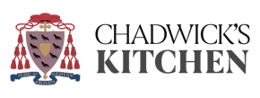
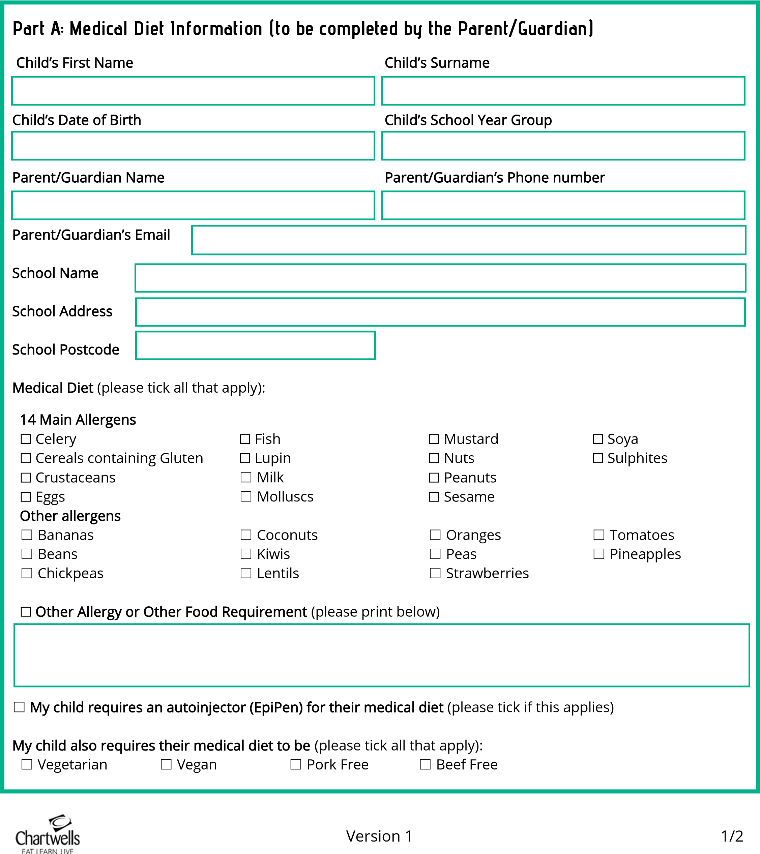
Bishop Chadwick allergen reports, declaring the presence of the 14 mandatory Food Information Regulations allergens, and nutrient counts (including carbohydrates, protein and fat) are available for all Chadwick’s kitchen recipes on current menus.
Part B: Supporting Documentation (to be provided by the Parent/Guardian)
Please attach photo here
I confirm that I am attaching medical information as evidence confirming the medical diet requested in part A
Please attach a recent colour passport style photo of your child for identification purposes.
(please tick one or more boxes as appropriate):
☐ Doctor/Dietitian Letter or note
☐ Other medical professional Letter or note
☐ Professional medical care or Allergy Action plan

☐ Medical Evidence Support Form

Part C: Terms and Conditions
By completing this medical diet request form, parents/guardians are consenting for an adapted medical diet menu to be prepared for their child and for their child to be identified as having a dietary requirement in accordance with the identification system operated at the school. The medical diet menu will continue until the Childs school are notified in writing otherwise. You will receive a copy of the medical diet menu and are required to notify any discrepancies immediately. If you do not notify any discrepancies prior to the menu start date, this will signify the acceptance of the medical diet menu. It is the parent/guardian’s responsibility to inform the school in the case of any changes to the medical diet requested for their child.
The school kitchen can provide a jacket potato with a suitable topping from the date of receipt of a medical diet request until the date a medical diet menu has been confirmed for a child. Otherwise, pupils must provide a packed lunch meal as an interim measure.
Bishop Chadwick reserve the right to decline a medical diet request if a risk assessment considers the medical risk too high, or the request process is not completed in full (for example if insufficient medical evidence is provided). In these circumstances, Bishop Chadwick may refuse to provide any diet to the pupil.
Bishop Chadwick will process the personal data you have supplied, in accordance with the data protection laws that apply to the UK. We do so to protect the vital interest of your child. We will only share this personal data with those people or organisations that may require it to keep your child safe and healthy. We will keep this personal data for no longer than is necessary, and at most for 3 years after they leave the school named on this form. Under UK data protection legislation, you have certain rights in relation to your personal data.

I consent to Bishop Chadwick processing this personal data for the purpose of providing a medical diet and I confirm that I have read and understood the above
Parent/Guardian Name

Signature

Date

Please return this completed form with supporting medical evidence to your school for it to be returned to the Catering team.

