Year 3 Newsletter
Spring Term 2023
Year 3 have worked their socks off this term. They have studied time and measure in Maths and have fully cracked their fractions unit. In English they enjoyed reading The Iron Man by Ted Hughes and ‘magpied’ its tricky vocabulary. They used this to write their own adventure story. We also enjoyed reading the book Charlie Changes into a Chicken as our class reader.
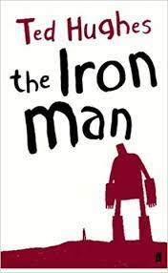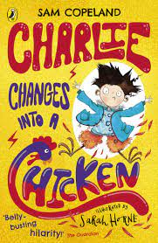
For World Book Day in March, we all dressed up as our favourite book character. We had a fabulous time.
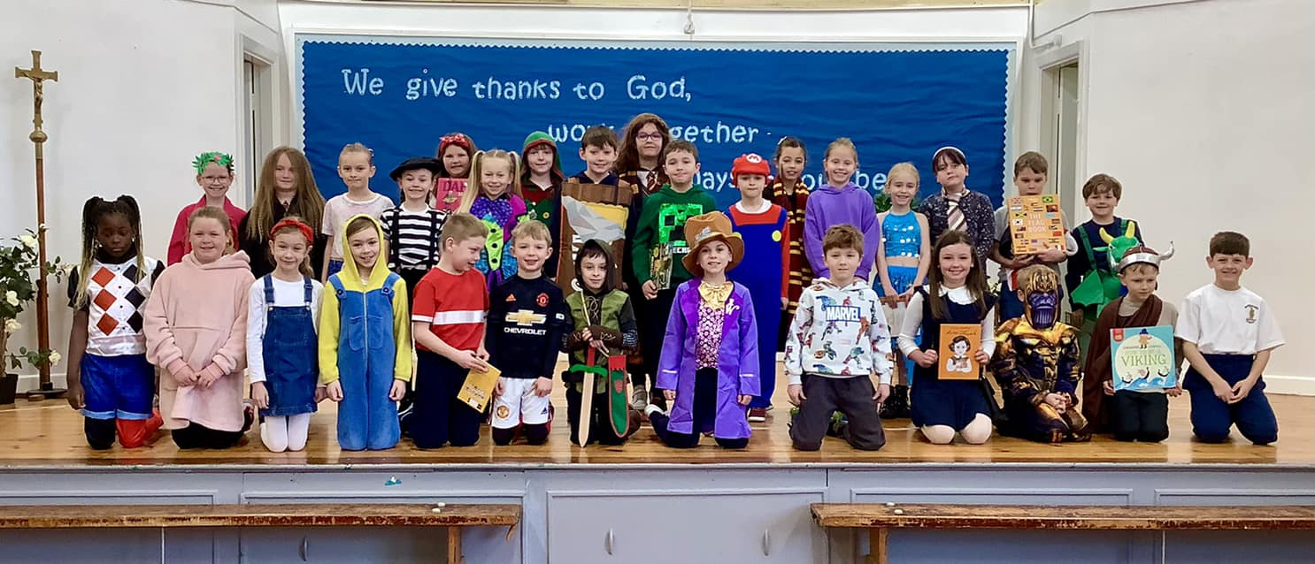
We Listened to Rik Mayall read George’s Marvellous Medicine by Roald Dahl and we had a visit from author Teresa Dewhurst who shared her book Slug with us and brought along some of her pet slugs to meet us.
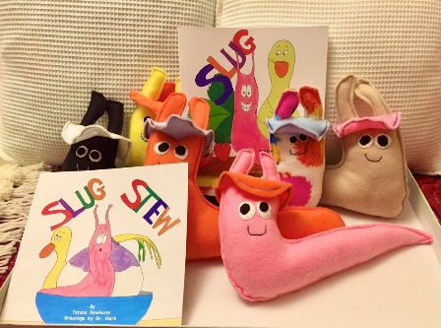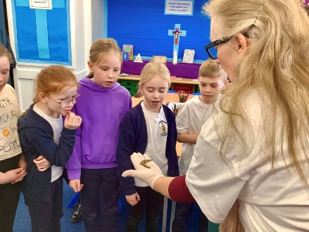
We also went to a book swap organised by our school librarians
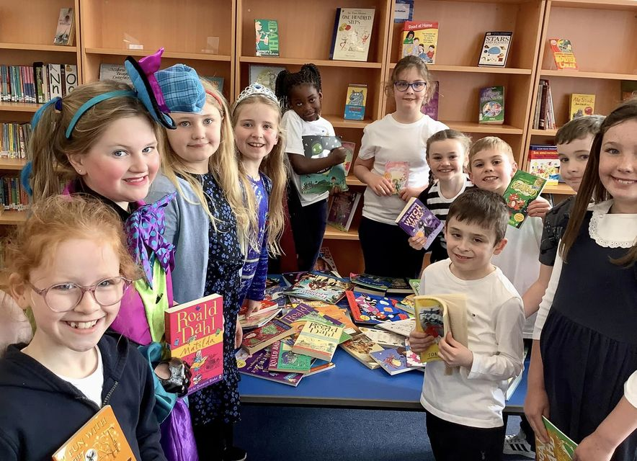
In Science we studied rocks and fossils with Miss Christie and Light with Mrs Squares. We enjoyed making our own fossils and experimenting with shadows.
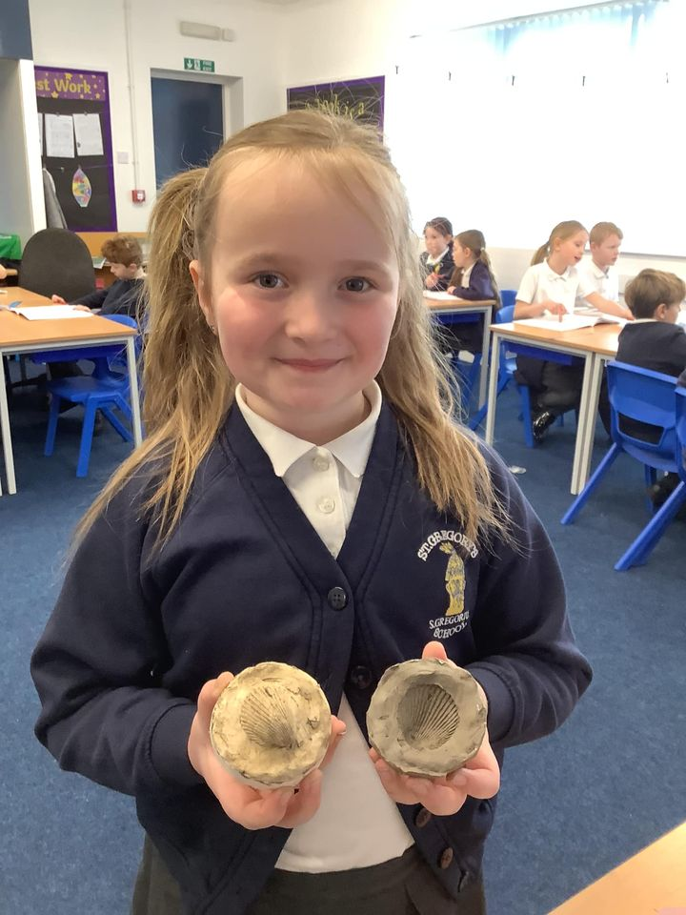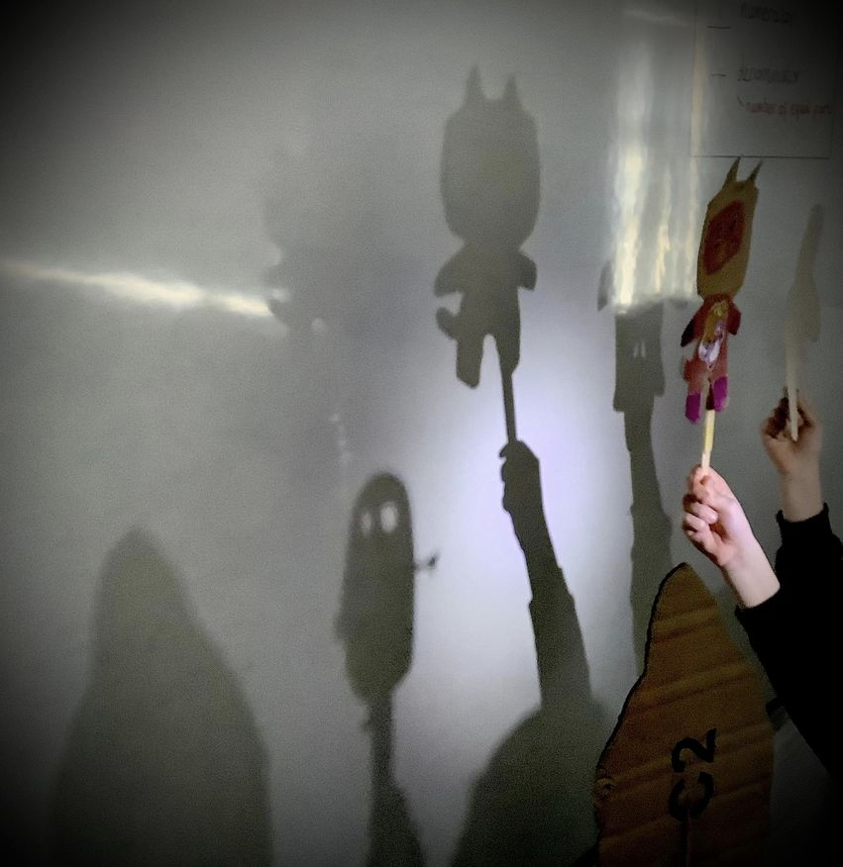

In art we’ve been looking at the work of Michael Craig Martin and Julian Opie. We created portraits in the style of Michael Craig Martin. Do you recognise anyone?
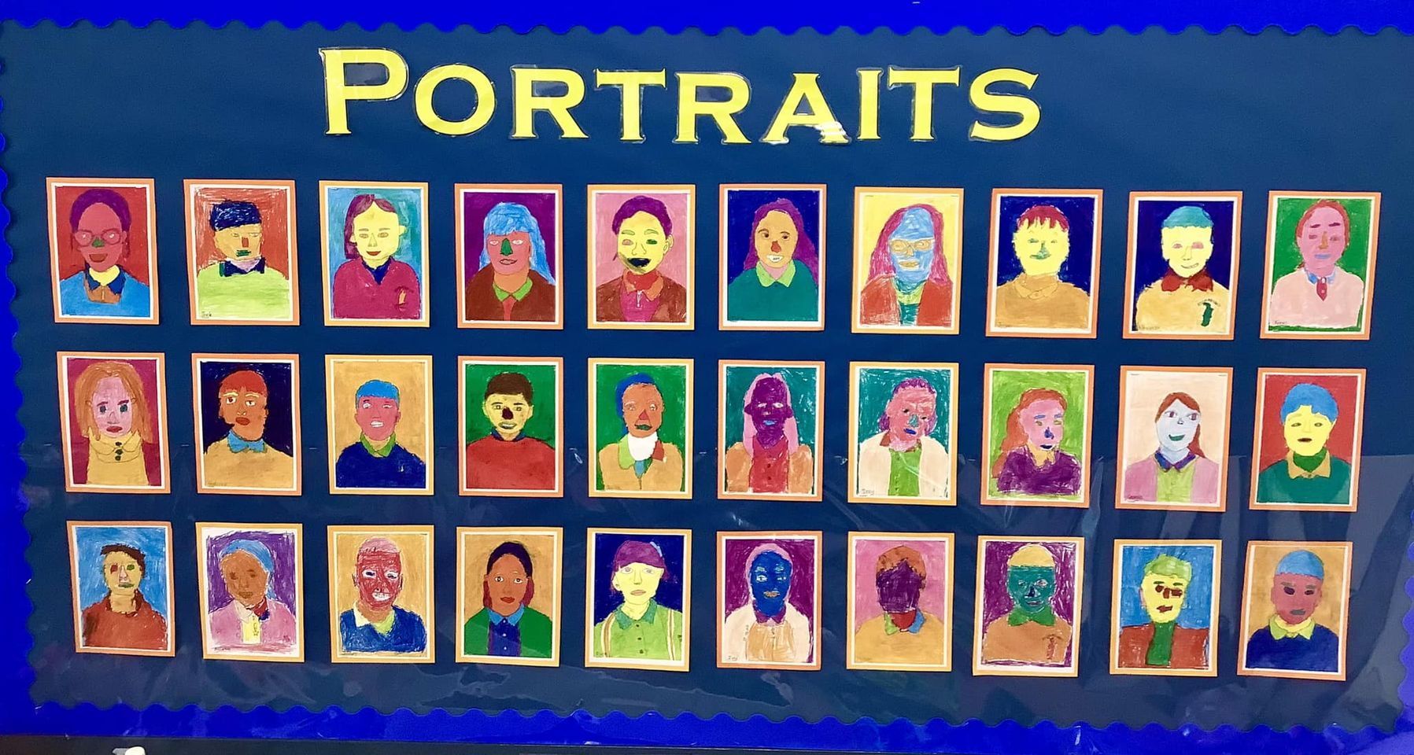

We went to Mass at St Gregory’s Church with Father Keith and the church members. They all made us very welcome and gave us drinks and biscuits afterwards. Fr Keith let us have a look at the fish in the church. We love the fact that our church has its own fish pond.

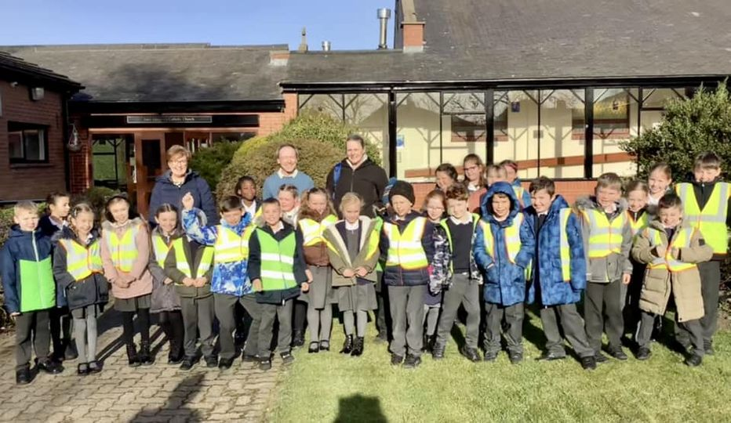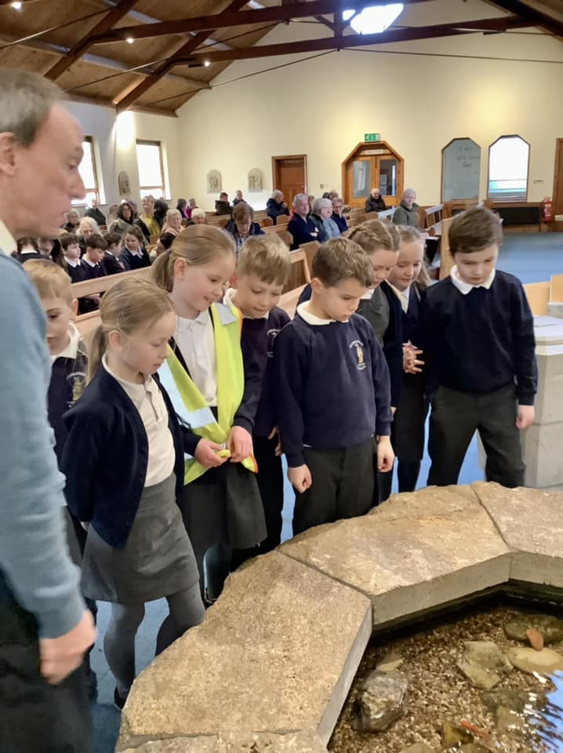

During Mental Health Week we tried to think of ways to focus on the positive things that happen each day. We made a lovely flower from all our positive thoughts. A group of us led class prayers and used our flower petals to help us all to pray to God to help us stay positive.
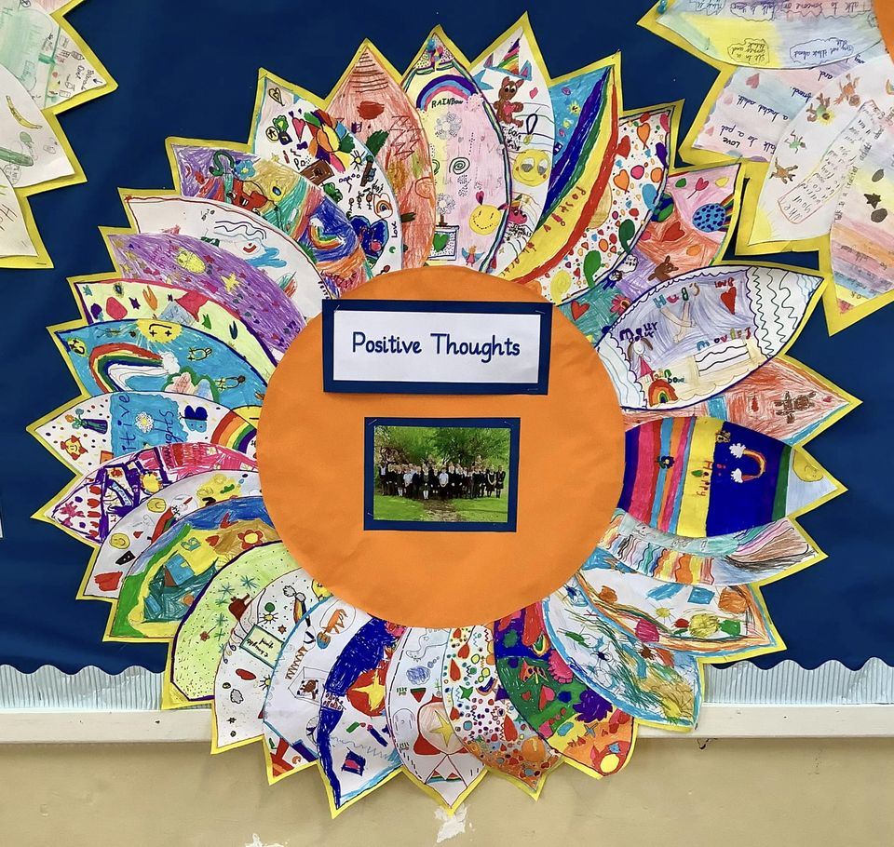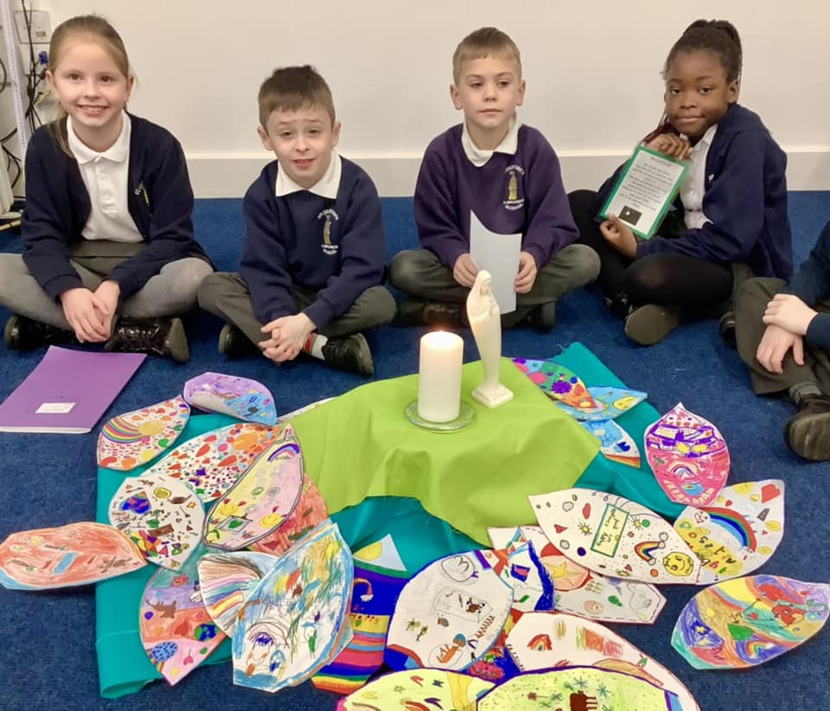
We all had a fun time dressing in red for Red Nose Day. We also took part in a charity walk to raise money for the CAFOD Earthquake appeal.
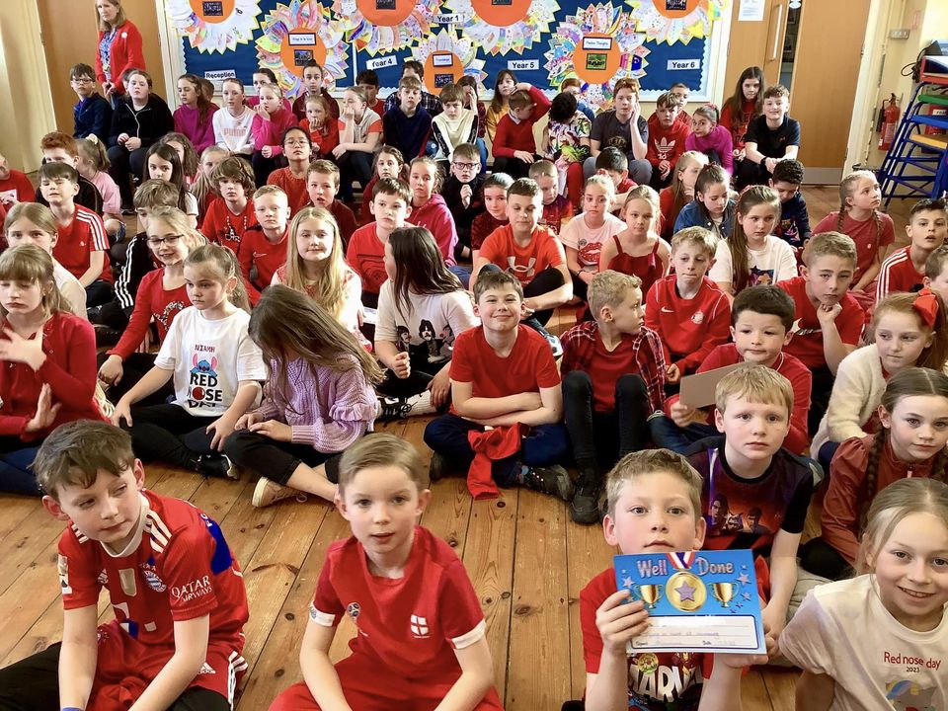

It’s been a fabulous term. We can’t wait for the Summer Term!

