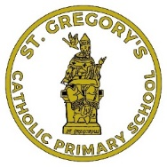
St Gregory’s Catholic Primary School

MISSION STATEMENT
By St. Gregory’s Pupils

St, Gregory’s Catholic School serves the parish of St. Gregory’s Church, South Shields.
Here at St. Gregory’s we help our children to understand more about God and how to follow in his way. We learn right from wrong and our pupils are always polite and respectful. No matter how we look or where we are from we are all God’s children. Our teachers ensure we have a healthy mind and body.
- We will try, at all times, to keep high standards, reach our goals and do our best for our school.
- We believe that every child has come from God and is part of God’s family and will live in heaven with God forever.
- Every child is special in their own way and they don’t need to prove themselves to be respected. Every child is unique in every way and in their own way. God doesn’t pick favourites, everyone is noticed by God.
- We think that all boys and girls, all around the world, rich or poor and of all abilities should always be treated the same.
- We all work together to be the best that we can possibly be. We purposefully use our gifts and talents and are honest and true to ourselves. We welcome and love all in school. SAPA, school staff, families, after-school clubs and providers, school governors and Father Keith all help us to be the caring school family that we are.

