Reception class newsletter
Week ending 12th May 2023
It’s been a busy couple of weeks in the Reception class. We’ve been working hard at our phonics and have learned some new digraphs. Please do check in your child’s blue phonics file a few times a week. You’ll see the sounds we’ve been covering and it would be great if you could ask your child to blend the words on the sheet and have a go at forming the letters correctly. We really do appreciate your support.
One of the highlights of last week, of course, was our red, white and blue day on Friday to celebrate the coronation of King Charles. We did lots of fun activities and enjoyed a lovely coronation picnic in the hall.
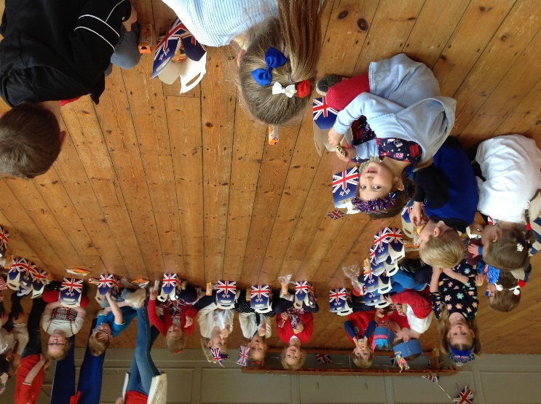
We have started having a weekly story session with our Y4 reading buddies. Reading and sharing stories is a huge priority for us in Reception. Our children have loved listening to their older buddies reading stories. Some of our little ones have also read their own reading books to their buddy. It’s a lovely way to spend twenty minutes on a Friday afternoon!
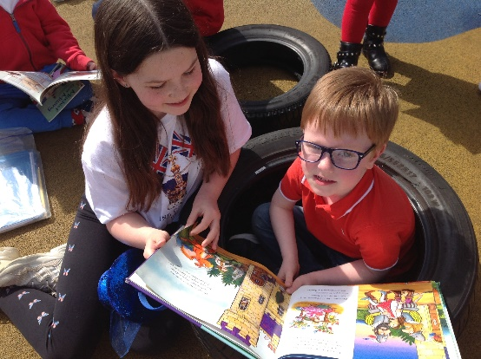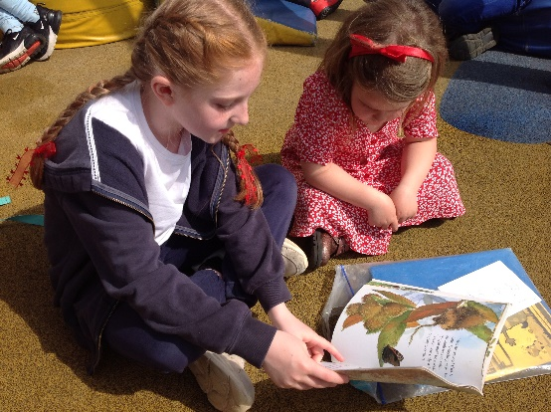

In maths over the past couple weeks we’ve been focusing on spatial reasoning and on adding numbers. For spatial reasoning we have used pattern blocks, tangrams, geoboards, magnatiles and large and small construction to investigate shapes and how they can fit together. If you don’t have any resources like this at home then there are some online pattern blocks to make pictures and patterns with at
https://mathsbot.com/manipulatives/patternBlocks.
You could try making a pattern/ picture for your child to copy. Encourage them to think about what shapes to use and where to place them in relation to other shapes.
In our work on addition, rather than focusing on writing ‘sums’ we’ve been doing lots of practical activities and telling addition stories such as ‘First there were 5 people on the bus, then 3 more got on. Now there are…?’. Some of our children have enjoyed challenges such as eg ‘We don’t know how many characters were on the bus first but we do know that 3 got on and we had 7 altogether. Lets work out how many were on at the start.’

We finished our ‘Good news’ RE topic with a lovely child led liturgical prayer. Hopefully your child has come home and told you some of the things they’ve learned. Perhaps you could ask them what happened in the story of Pentecost day.

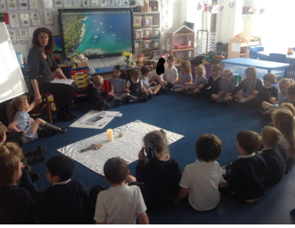
Have a lovely weekend everyone!

